**PROJECT TITLE:**

**STUDENT DATA MANAGEMENT SYSTEM**

**Project Manager(s):**

**B.Sathvik Kumar(19-1204) and A.Naveen Kumar(LE-1202)**

**Project Summary**

* A student database management system is **designed to make the management of student data** such as storage, tracking, and monitoring information simple and easy. It also enables school authorities to share relevant information with students, teachers, and parents.

We have spent lot of time to complete this project. This project helped us to experience the real time scenarios.

We have done the work with both FUN and FRUSTATION.

We have got a very beautiful experience with this….Thank you sir for giving this opportunity for us.

This project is done by Using java , servlets , jdbc ,SQL ,Tomcat server,Xampp server , html and xml.

For Accessing the Data we need to login first.

This Project has 2 ways to view the data…Either the user needs to be faculty or student .

For faculty we have given all the possible options even to update but the student can only view the data but couldnot change or update .

For Faculty login Passwords are “password” “pass” “admin”.

Anyof these three can be used .

For student Login Passwords are “anurag”, “admin”.

Either of the one can be used.

Step 1:We need to select any of the option .

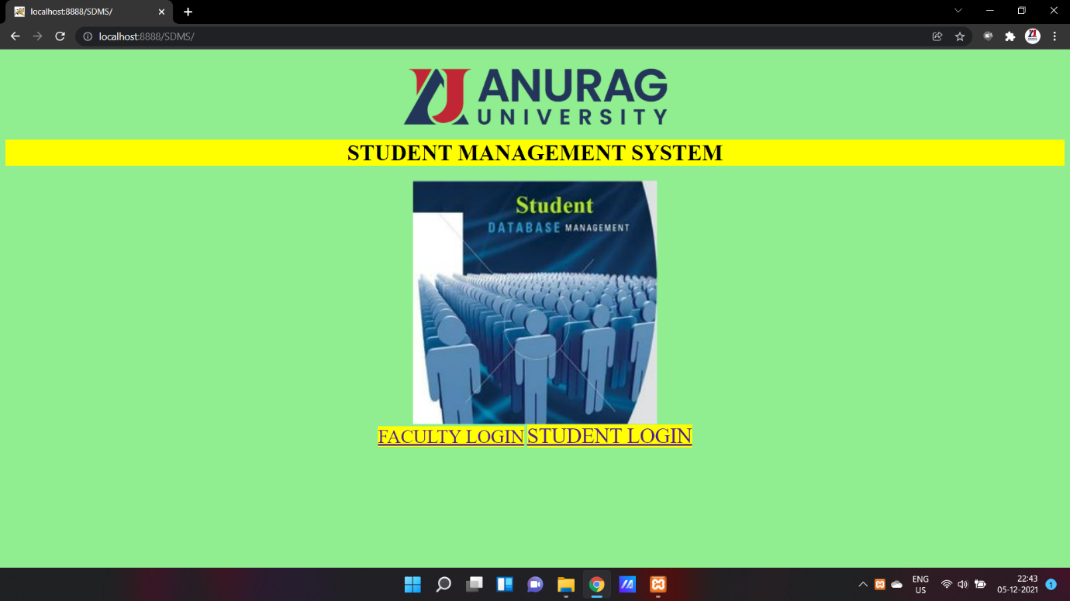

Step 2: If we select FACULTY LOGIN.

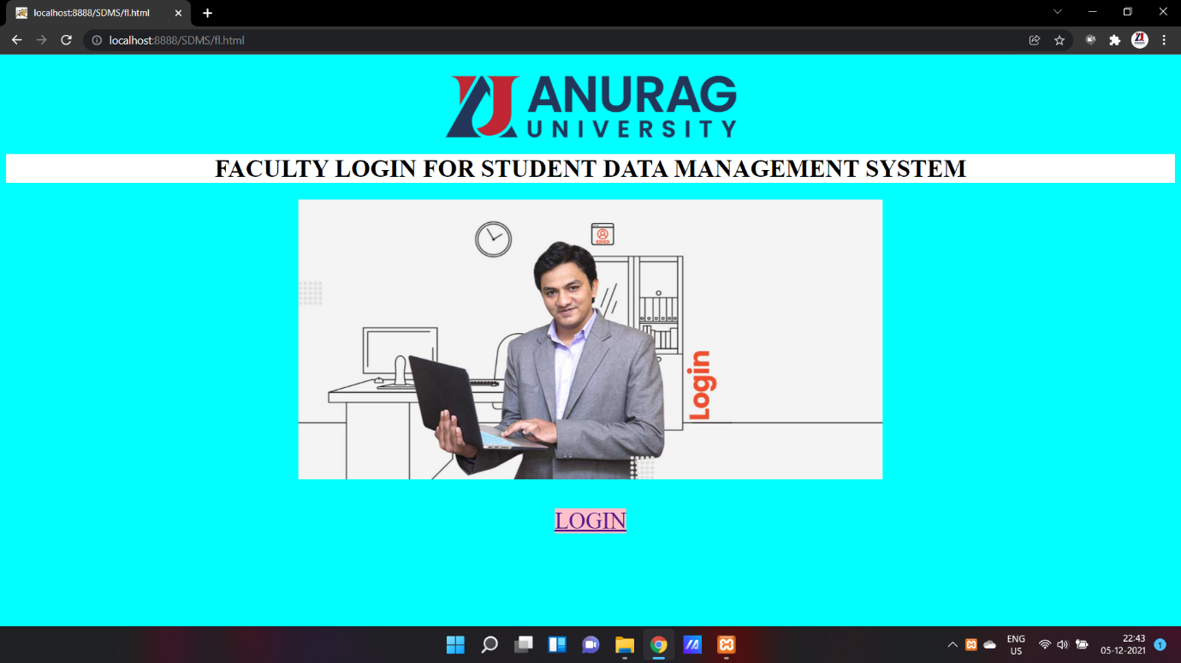

Step 3: Select Login

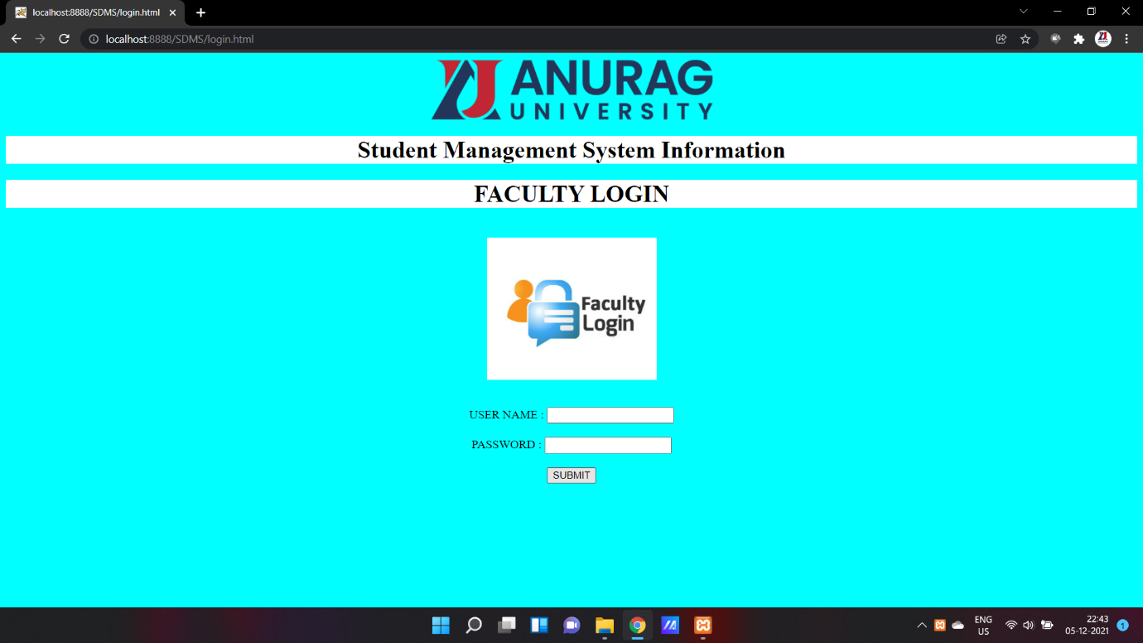

Step 4: Enter username and Password and click on submit. The below shown figure is the home page.

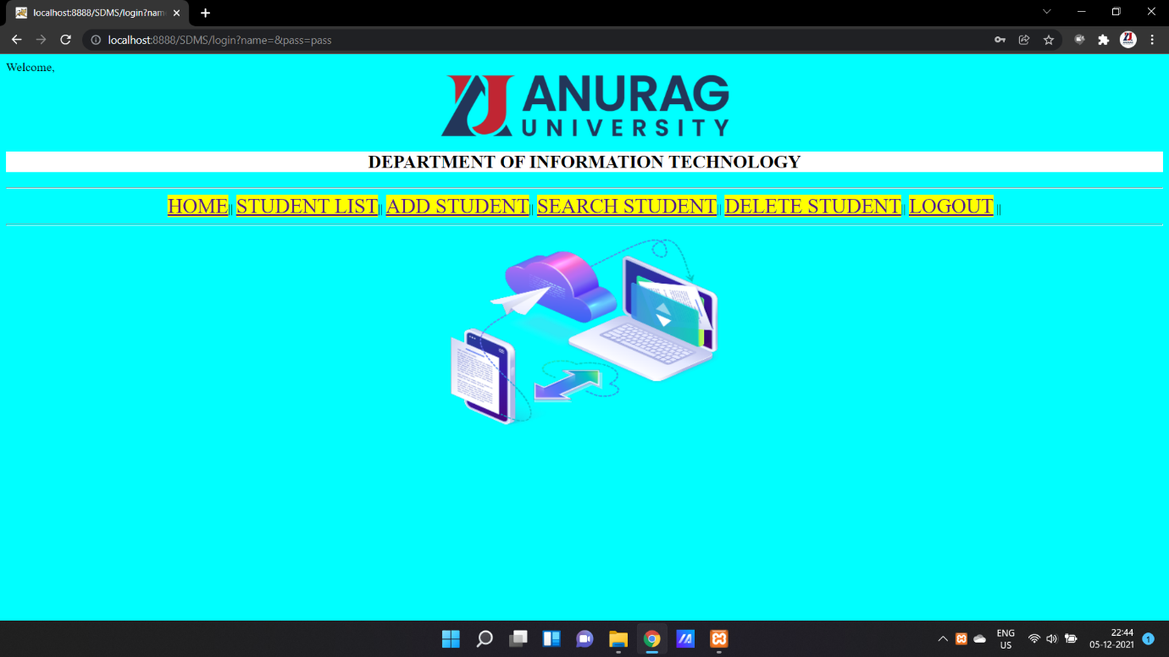

Step 5:As per options we see the below pages:

1. List of all Students

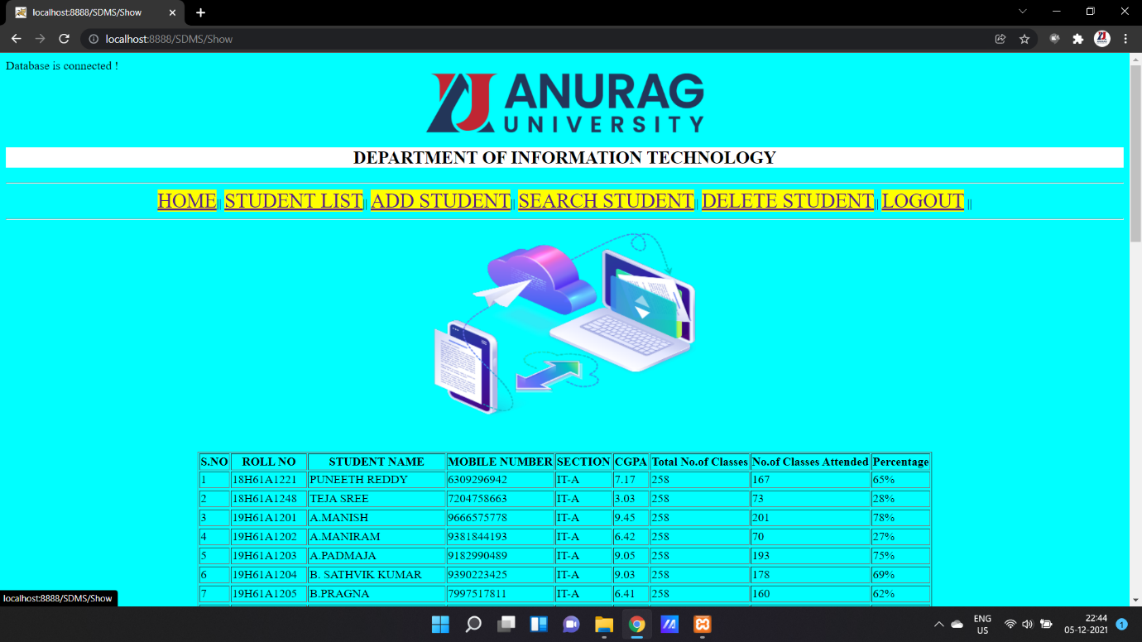

1. Insertion of student data

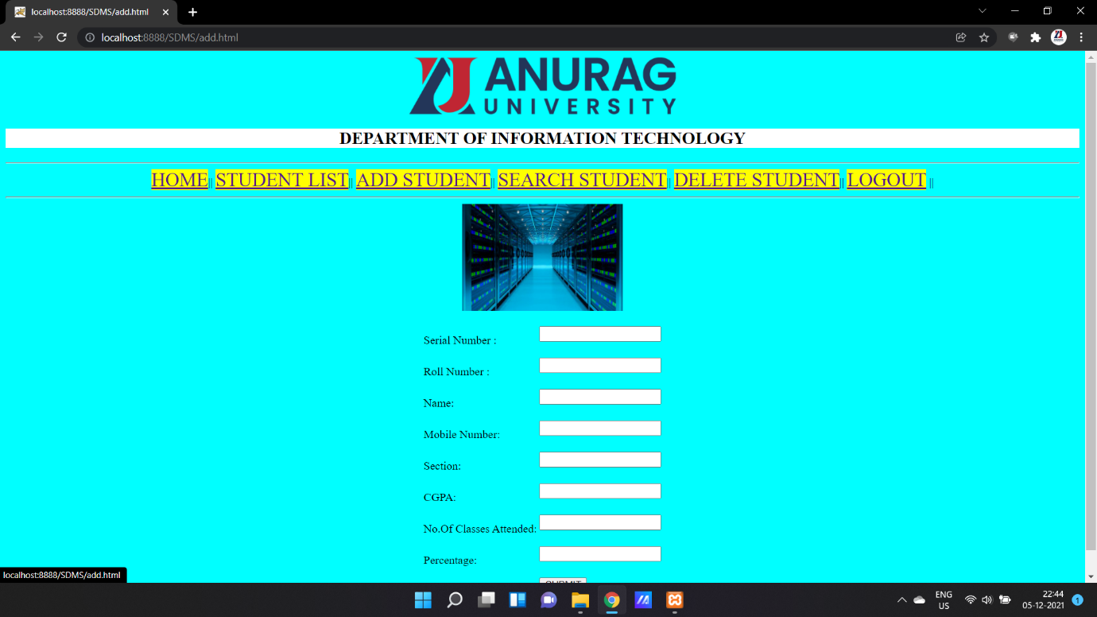

1. After clicking submit button in add student page.

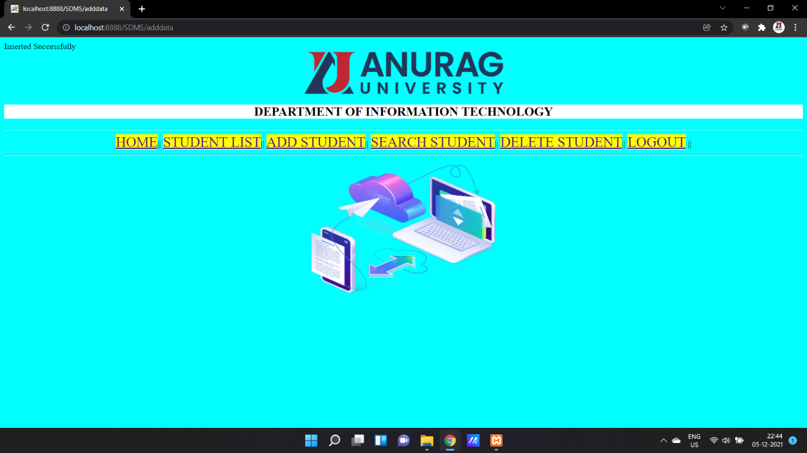

iv)Searching the student details.

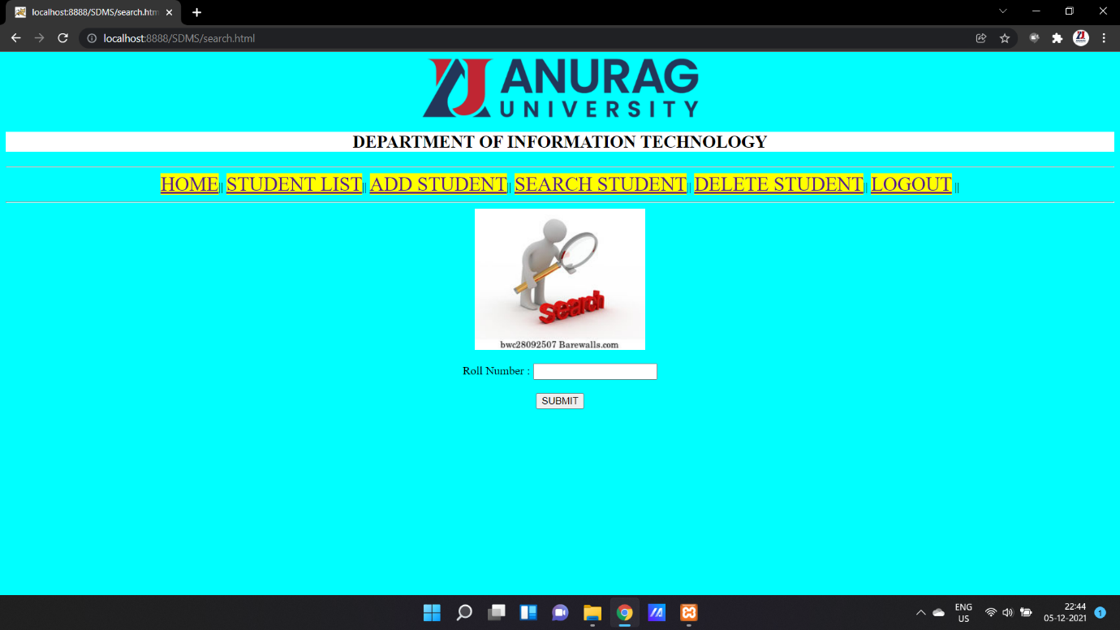

v)Result of Search.

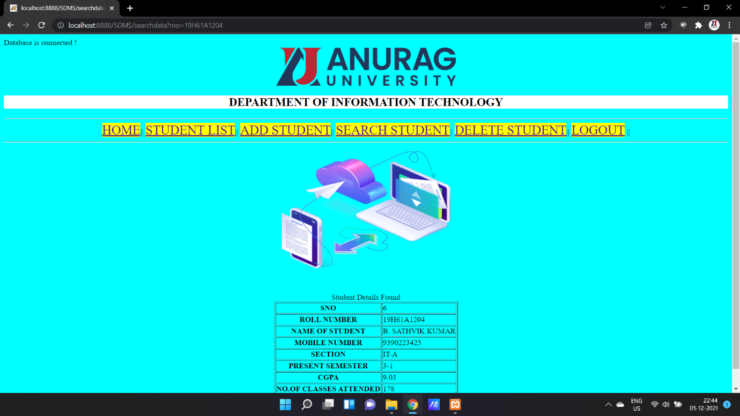

vi) Deleting the Student Detail.

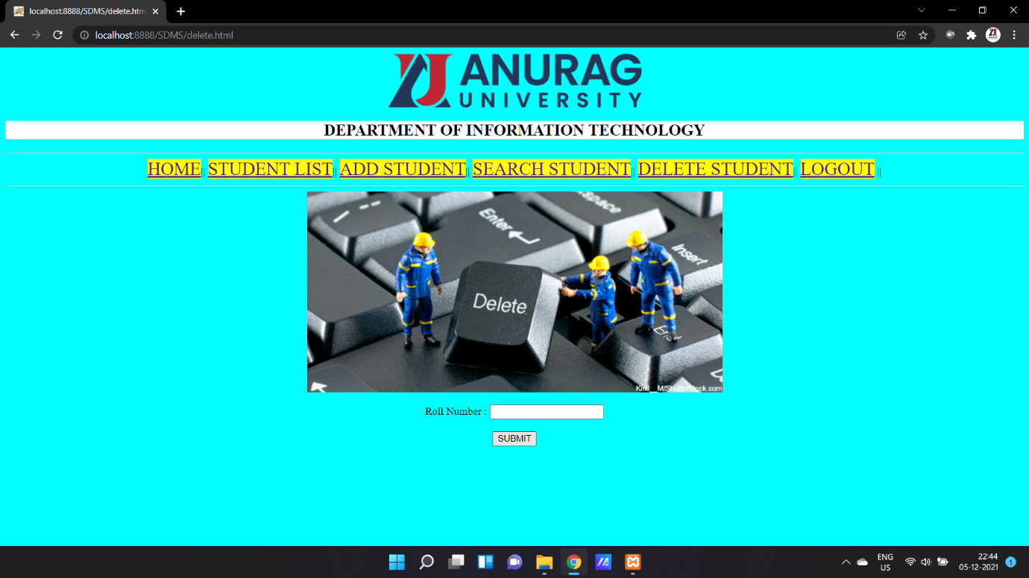

vii) Result after Deletion

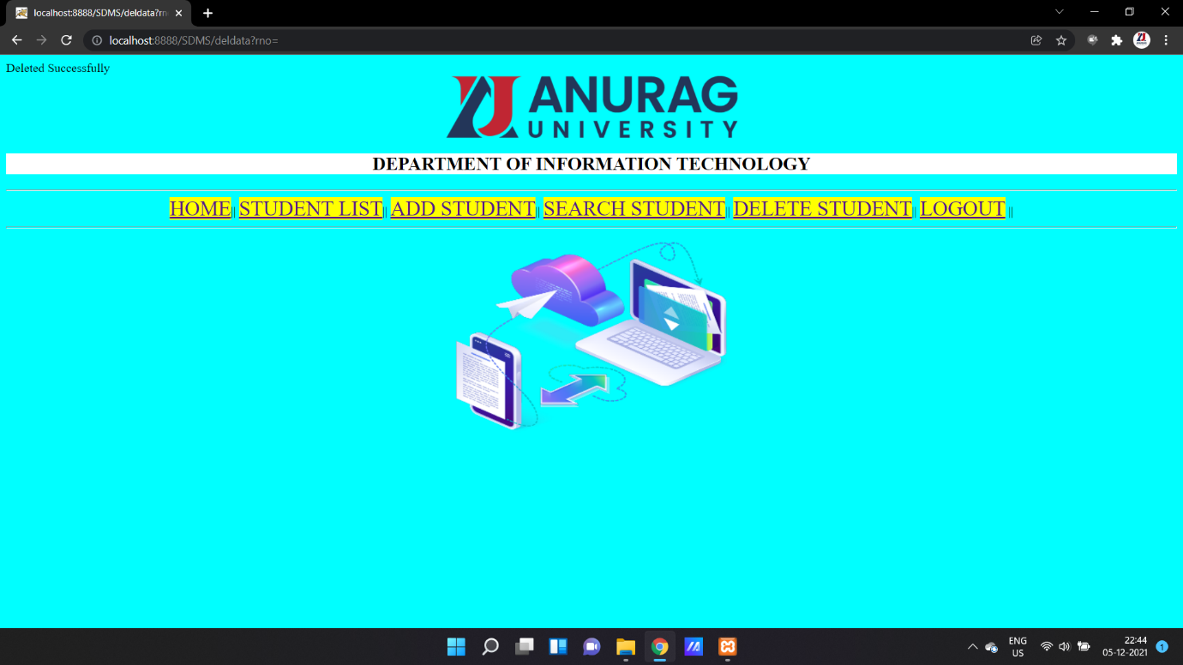

Step 6: After LOGOUT

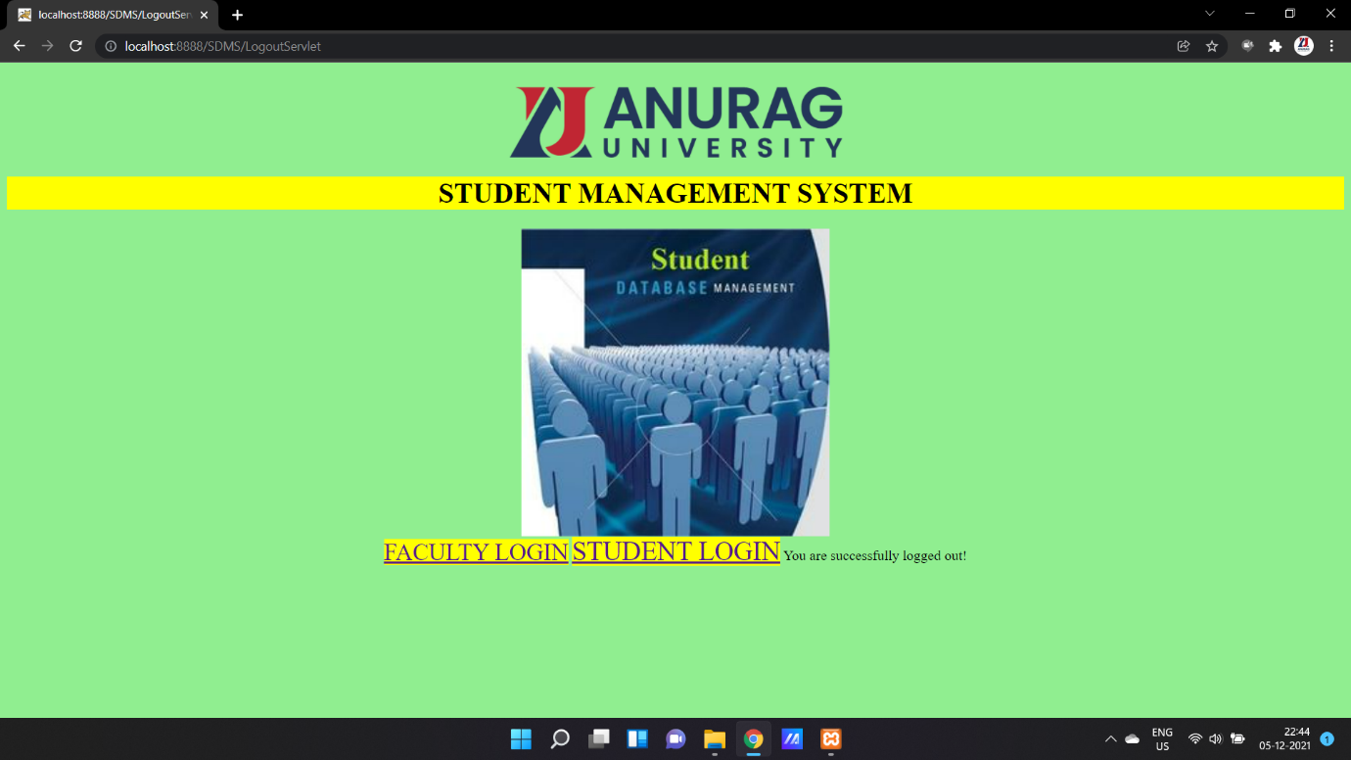

Step 1: Selection of Student Login

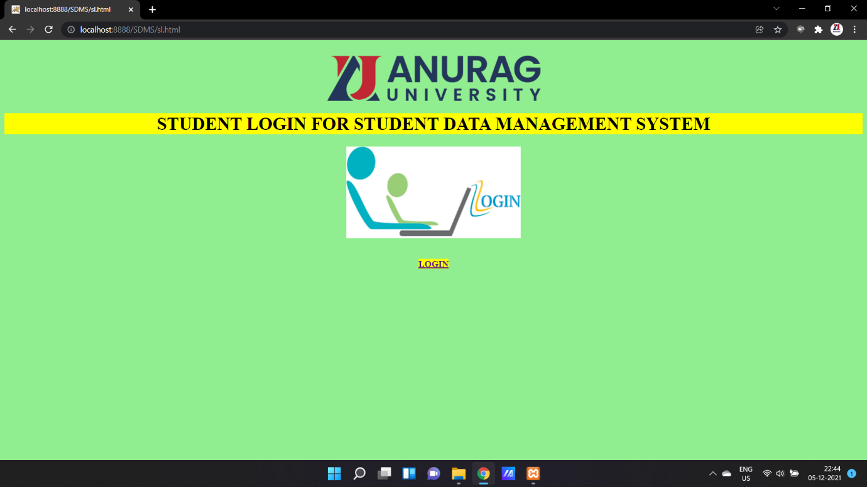

Step 2:Click on Login and Enter Username and Password.

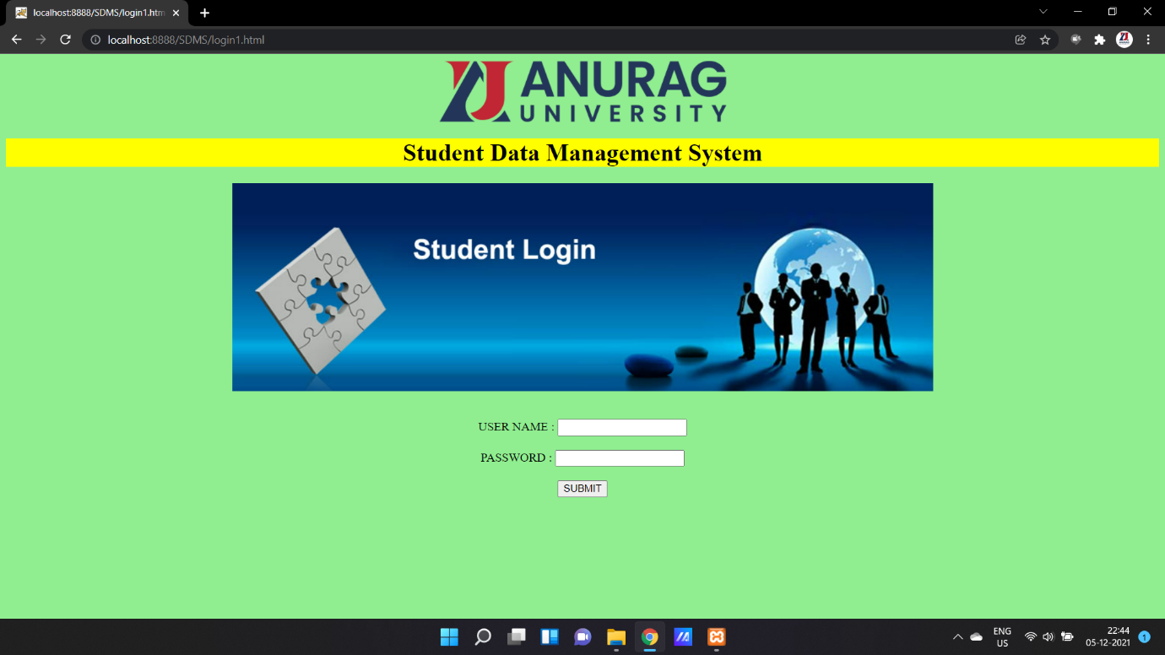

Step 3:Home Page for Student Login

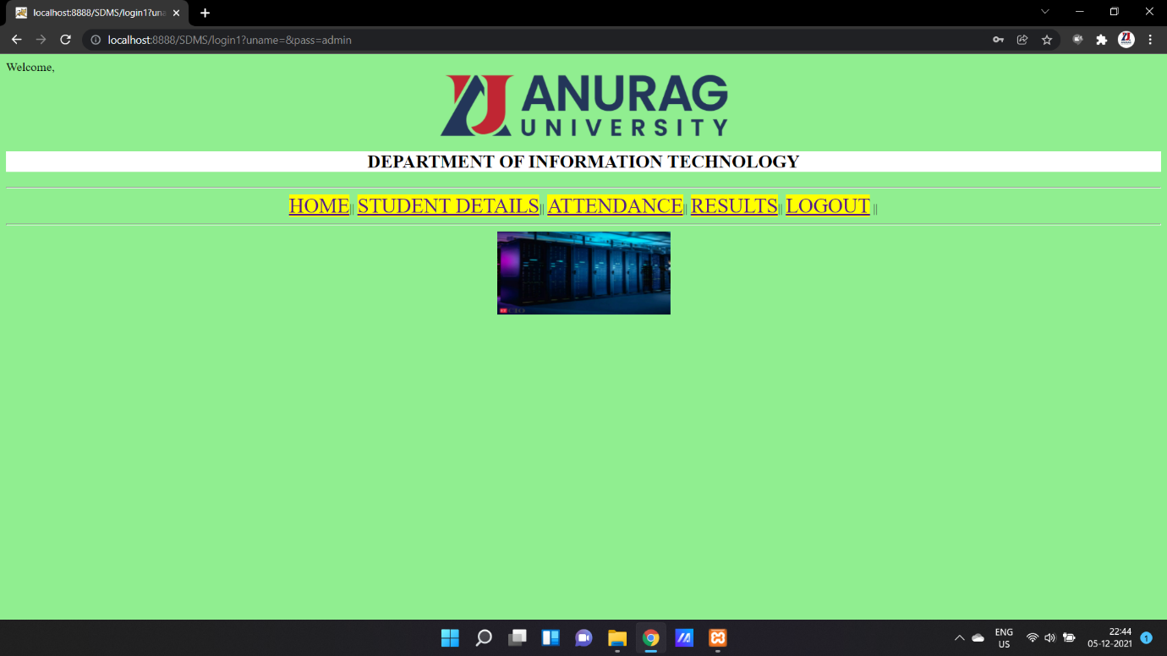

Step 4: As per options we see the below pages:

a)STUDENT DETAILS enter roll number.

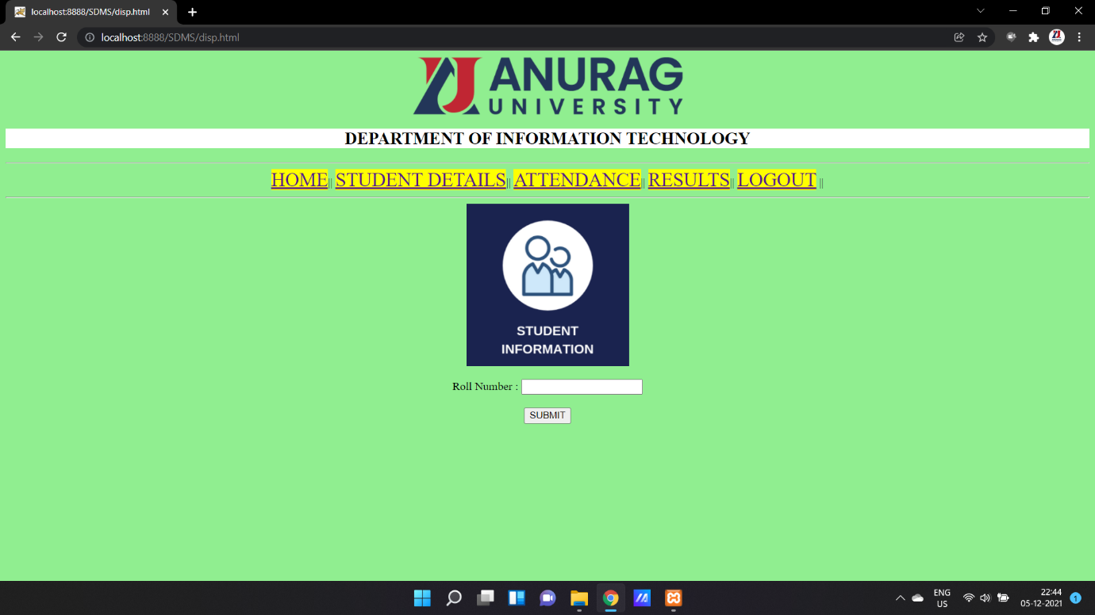

b) Result for above condition

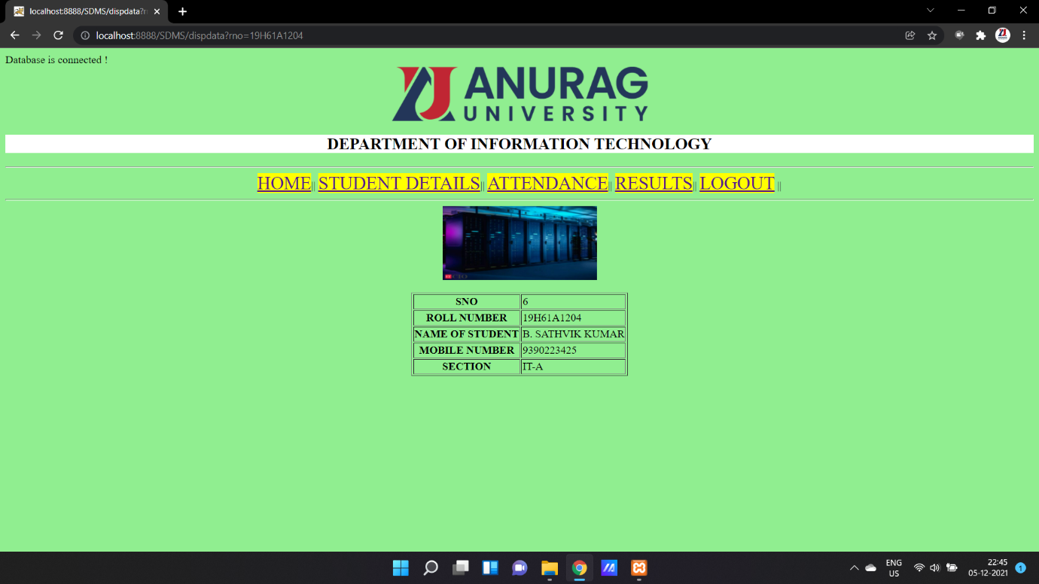

c) ATTENDANCE and Result 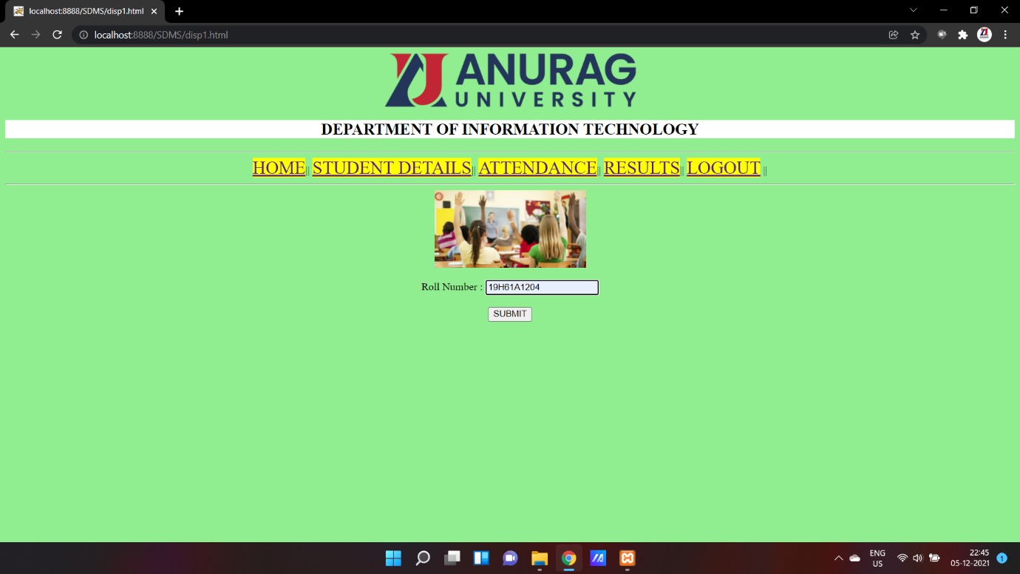

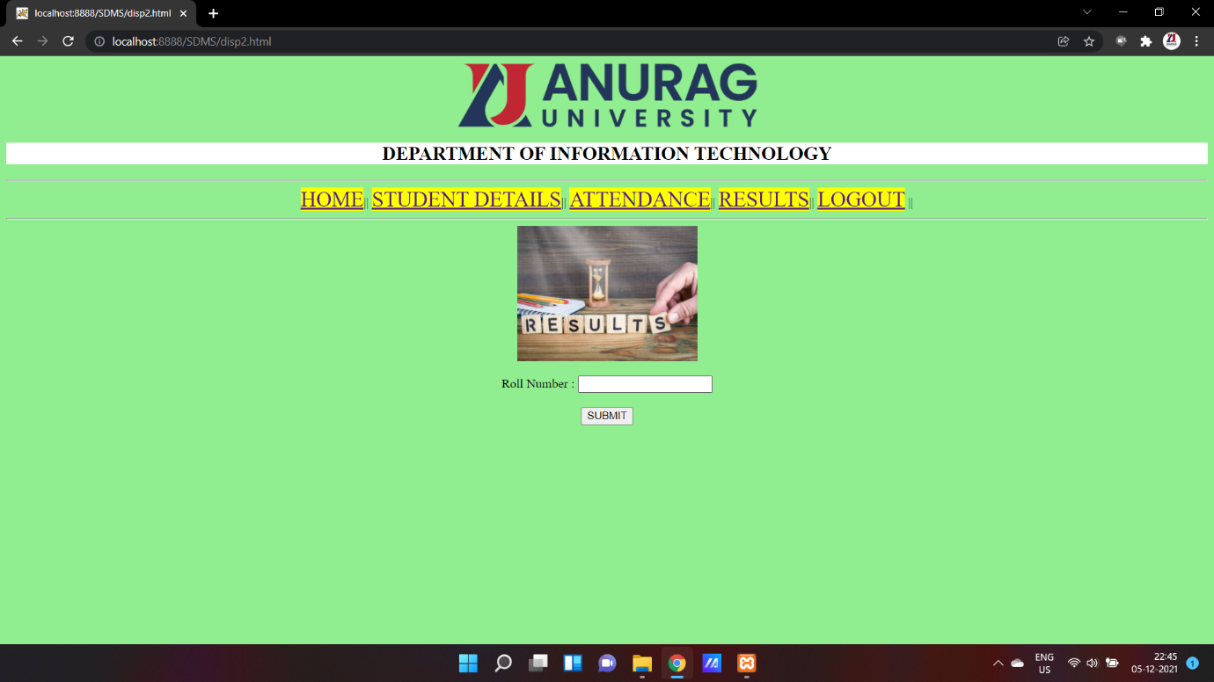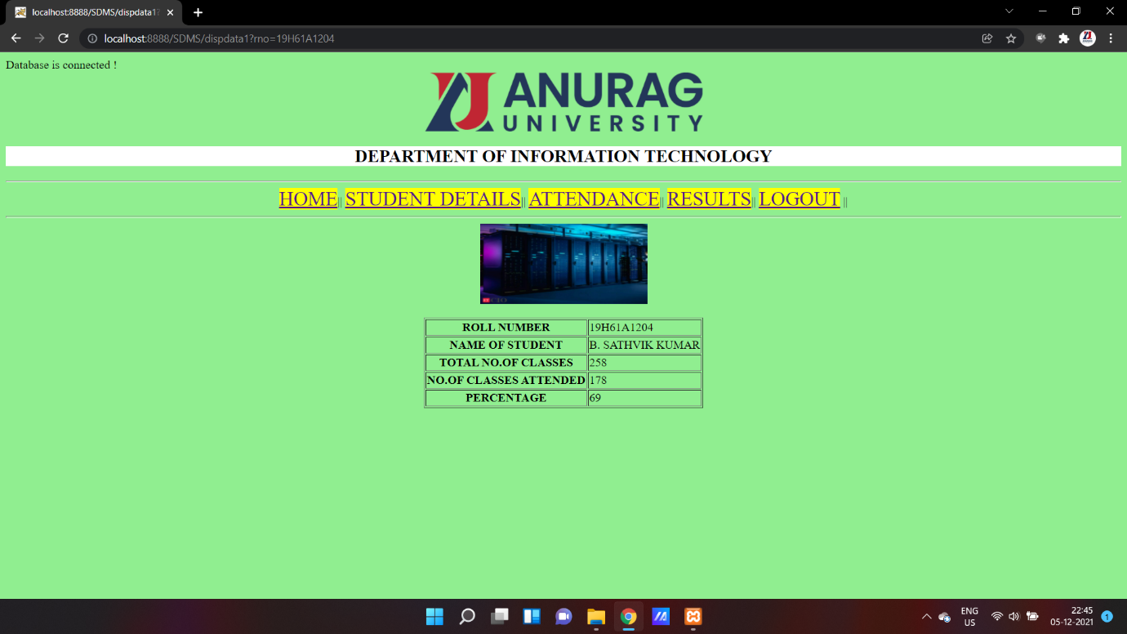

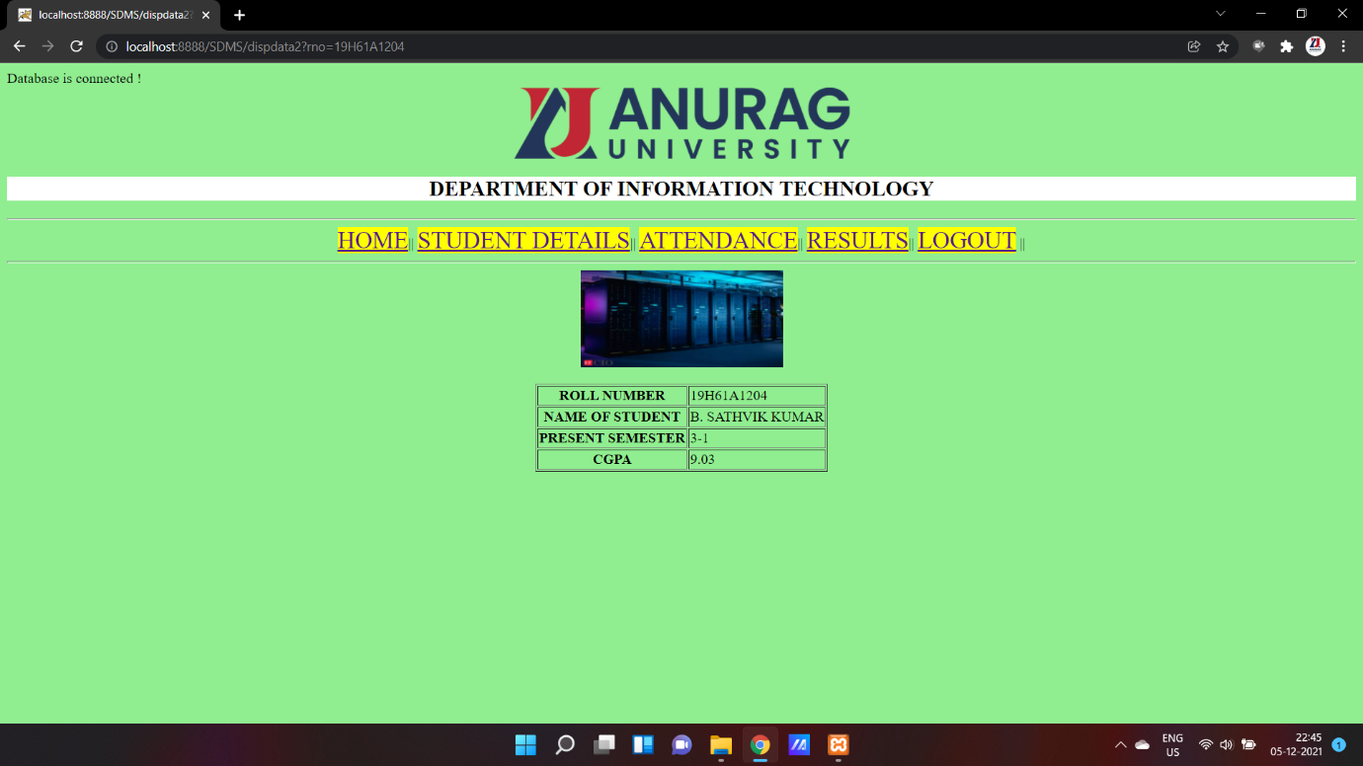

Step 5:

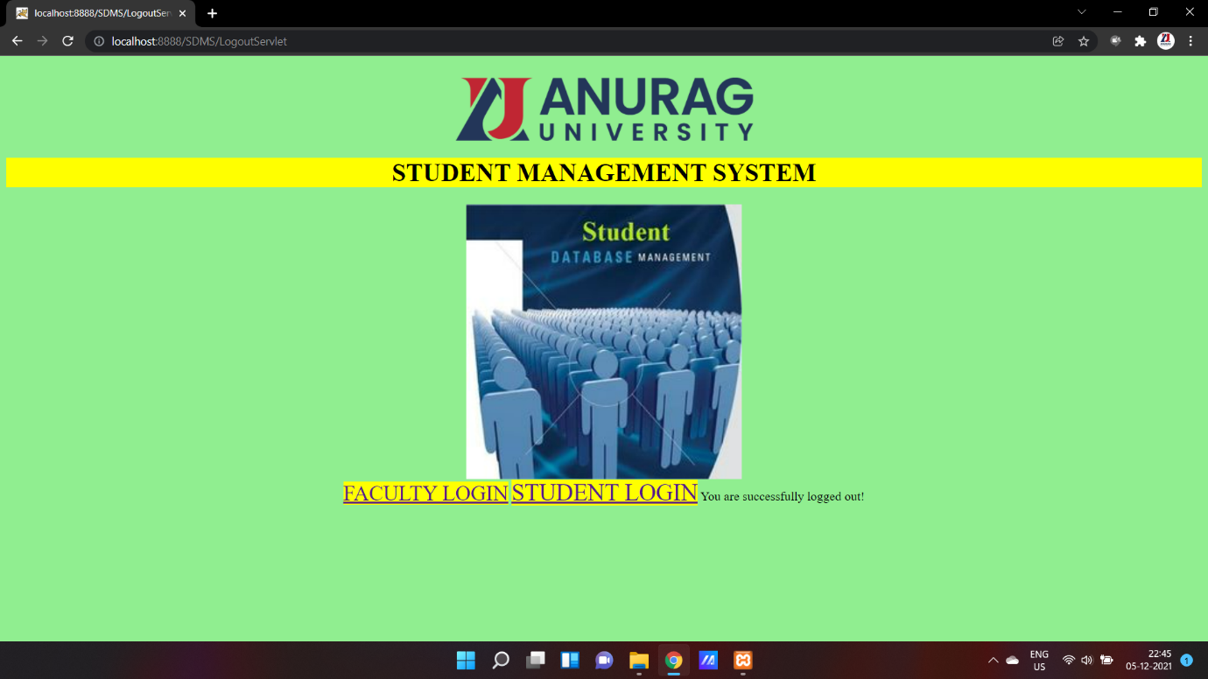

THANKING YOU

***THE END***